Full Name (in block letters) : THANIGAIVEL G
Affiliation : Vels University
Address for Communication : No. 50; Nehru Bazaar St, Vengal -601103.
Pincode : 601103
Contact No. : 8608969313
E-mail : thanigaivelrubesh1@gmail.com
Paper ID :

Title of the Paper : A Low-Code Framework for Conversational AI Assistants

Leveraging Retrieval-Augmented Generation and LLMs

Mode of Presentation : ONLINE/ OFFLINE
Registration Fee Details
Payment Details: Online Payment
Online Payment Transaction No.: 524932878461 Amount: 500
Date : 06/09/2025
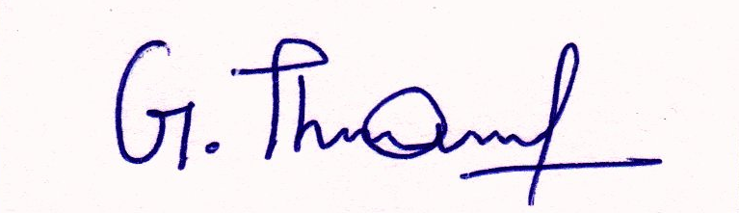
Note: Enclose the online transaction proof.

Signature

